SCRUM: Scrum is an Agile framework that makes teams to collaborate and work together effectively to deliver an end product.

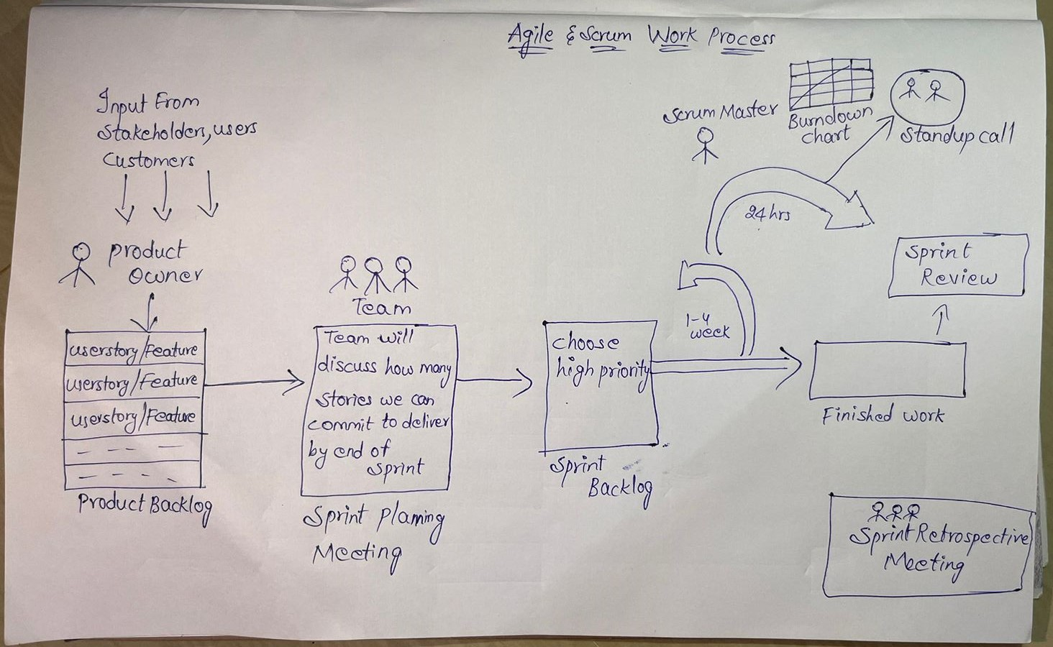

KEY COMPONENTS OF SCRUM:

\*ROLES: Product Owner, Scrum Master, Dev Team

PRODUCT OWNER ROLE AND RESPONSIBILITIES:

=>Set Product Goals

=>Defines the work to be done. How the product should look like. What features should it contain

=>Creates/owns/manages/maintains and prioritizes product backlog

(Product Backlog: whatever product we have to develop, that will be divided into different stories or features)

Example: if we have 50 user stories in product backlog, then PO will manage which should be completed first in the coming sprint. So PO will set priority which user story should complete first.

=>Should be available to team and stakeholders.

=>Agree on sprint goals with developers

=>Collect feedback from users, customers, stakeholders on product increments

=>Regularly update and refine backlog together with developers

=>Take decisions on what should be added and not added

=>Saying no to customer if it does not bring much value to product

=>Handles sprint review

SCRUM MASTER ROLE AND RESPONSIBILITIES:

=>Keeps the team focussed

=>Prevents team from distractions. Remove blockers that prevents progressing work.

=>Makes team highly performable.

=>Coaches on scrum processes. Make sure everyone follow scrum practices.

=>Facilitator for the team and product owner.

=>Supports team in self organizing.

=>Helps PO to find effective techniques to manage product backlog effectively.

=>Conduct scrum events.

=>Goal and scope of project is understood by everyone in the team.

=>Make sure every team member understands scrum.

DEVELOPMENT TEAM ROLE AND RESPONSIBILITIES:

=>team contains 3 to 9 members.

=>responsible for building actual product increment

=>decide how to accomplish the work set by PO.

=>Team manages itself and cross functional which owns collective responsibility of developing, testing and releasing an product increment.

=>manages sprint backlog.

\*ARTIFACTS: Product Backlog, Sprint Backlog, Increment

1)Product Backlog: A prioritized list of features, enhancements, and bug fixes, maintained by the Pr0duct Owner. Each item in the backlog is a user story.

Start with the two "R"s:

A team's roadmap and requirements provide the foundation for the product backlog.

Roadmap initiatives break down into several epics, and each epic will have several requirements and user stories.

The backlog serves as the connection between the product owner and the development team.The product owner is free to re-prioritize work in the backlog at any time due to customer feedback and new requirements.

Once the product backlog is built, it's important to regularly maintain it to keep pace with the program.

Product owners should review the backlog before each iteration planning meeting to ensure prioritization is correct and feedback from the last iteration has been incorporated.

2)Sprint Backlog: Selected items from the product backlog for a specific sprint, chosen by the Development Team during Sprint Planning.

The purpose of a sprint backlog is to define work items to tackle within the sprint.

This keeps information in one shared space in order to streamline communication and create one central source of sprint information.

Create a sprint backlog during the planning phase of a new project sprint. While you can update individual tasks with details and

additional progress during the sprint, the backlog itself shouldn't alter during execution.

3)Increment: The sum of all completed user stories and features at the end of a sprint. Each increment should be a potentially shippable product.

it works with all the other Increments. In order to provide value, the increment must be usable.

The Increment is the sum of all Product Backlog items Done during a Sprint and the value of all the previous Increments.

An Increment is created the moment a Product Backlog item meets the DoD(Definition of Done).

The DoD is a commitment that Scrum Team has toward the Increment.

\*EVENTS:

Sprint: A time-boxed period (usually 2-4 weeks) during which a potentially shippable product increment is created.

Sprint Planning: At the beginning of each sprint, the team plans the work to be done during the sprint.

Daily Scrum: A brief daily meeting where the team discusses progress, plans for the day, and identifies any obstacles.

Sprint Review: At the end of each sprint, the team presents the completed work to stakeholders for feedback.

Sprint Retrospective: A meeting after the sprint review where the team reflects on the sprint, discusses what went well, and identifies areas for improvement.

SCRUM METHODOLOGY:

1. Start with a Product Backlog:

Create a list of features, enhancements, and fixes needed for the product. Prioritize them based on business value and customer needs.

2. Sprint Planning:

At the beginning of each sprint, the team selects a set of items from the product backlog to work on during that sprint. These become the sprint backlog.

3. Daily Scrum:

Every day, the team meets for a short daily scrum to discuss progress, plans, and any obstacles. This helps in keeping the team aligned and focused.

4. Sprint Execution:

The Development Team works on implementing the selected items from the sprint backlog, aiming to deliver a potentially shippable product increment by the end of the sprint.

5. Sprint Review:

At the end of the sprint, the team presents the completed work to stakeholders for feedback. This allows for continuous validation and adjustment of the product.

6. Sprint Retrospective:

The team reflects on the sprint, discusses what went well and what could be improved. This learning process contributes to continuous improvement in future sprints.

7. Repeat:

The cycle repeats with the start of a new sprint. The product backlog is adjusted based on feedback and changing priorities.

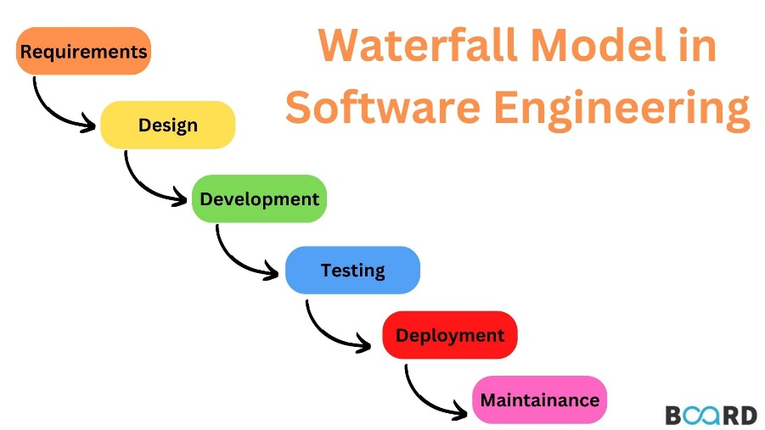

Disadvantages:

No back tracking.

Taking long time to complete

There is no collaboration & communication with other teams.

AGILE:

Agile is a group of methodologies that demonstrate a commitment to tight feedback cycles and continuous improvement.

Agile methodology process is like iterative and increment.

Agile main goal is customer satisfaction, why because here we wont release entire software/product at a time. A piece of software is delivered continuously every 2 weeks(sprint)

Whatever customer need requirements that is developed and delivered.

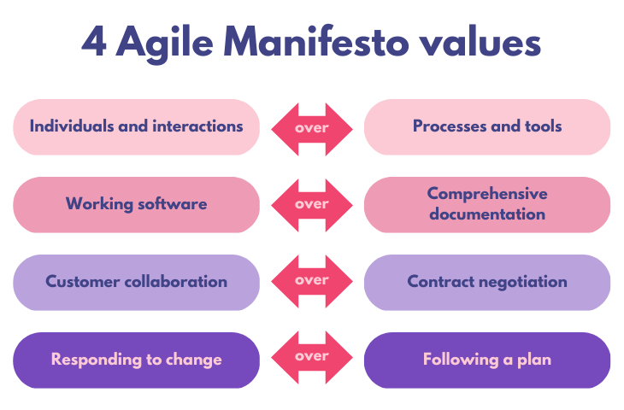

AGILE PRINCIPLES:

Principle#1: Customer Satisfaction

Our highest priority is to satisfy customer through early and continuous delivery of valuable software.

Principle#2: Accept changes in Requirements

Welcome changing requirements, even late in development.

Principle#3: Deliver value Frequently

Deliver working software frequently, from a couple of weeks to a couple of months, with preference to the shorter time scale.

Principle #4: Work Together

Collaboration & communication with various teams.

Principle #5:

Build projects around motivated individuals, give the environment & support they need, and trust to get the job done.

Principle#6: Encourage face to face interaction

The most effective and efficient method is conveying information to and within development team is face to face.

Principle#7: Measure Progress

Working software is the primary measure of progress.

Principle#8: Sustainable Development

Principle#9: Technical Excellence

Principle#10: Keep the work simple

Principle#11: Self organized teams

Principle#12: Reflect and Improve

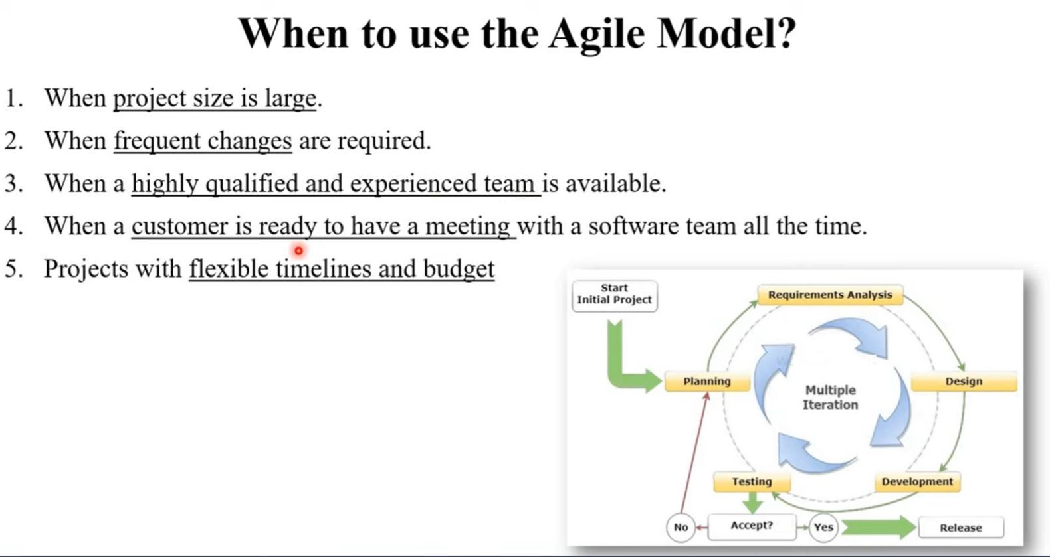

Advantages of Agile Model:

=>Supports customer involvement and customer satisfaction

Strong communication of software team with customer

Little planning required

Efficient design

Anytime changes are acceptable

Updated versions of functioning software are released every week

It reduces total development time